CONSIDERATIONS REGARDING THE COST OF LIVING APPLIED BY THE UNJSPF TO SPAIN IN THE LAST YEARS

In the following pages I show that the reduction of 2.8% applied by the UNJSPF to the cost of living (COL) in Spain in April 2015 was not justified by the real evolution of the CPI in this country. The conclusion is that the purchase power of retirees in Spain has diminished by 2%, and that such reduction is becoming apparent with the ongoing devaluation of the dollar. A solution is proposed to correct this mistake.
Summarizing, after many emails, I got the following explanation from the UNJSPF: Yes, the -2.8% decrease was a mistake, but so it was the +2.9% applied in April 2013, so there was no need to correct anything. I don’t agree.
(All the following screenshots have been obtained at the web of the INE (Spanish National Institute of Statistics: http://www.ine.es/varipc/)

2011 – 2012
Here is what we get when using the INE calculator:
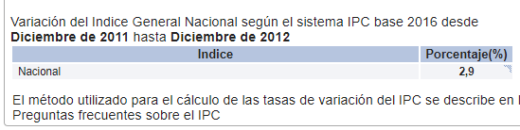
Look also at the following graph, also from the INE :
(http://www.ine.es/daco/daco42/daco421/ipc0012.pdf).
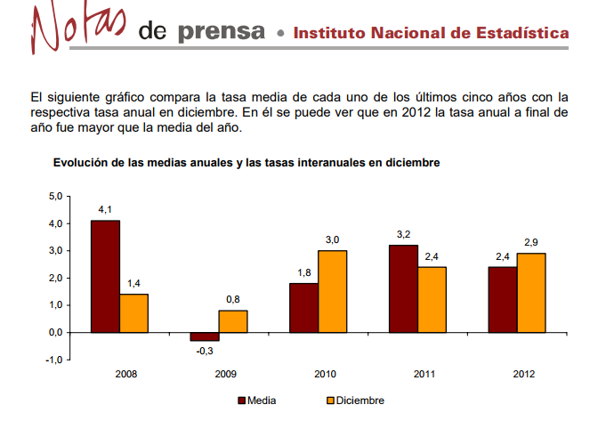
So, between December 2011 and December 2012 the index DID increase by 2,9%. It was NOT a mistake.
2012 - 2014
According to the UNJSPF data, between 2012 and 2014 the CPI decreased by 0,8% [(106.8-107.6)/107.6]. And that’s exactly what we get when using the calculator of the INE web:
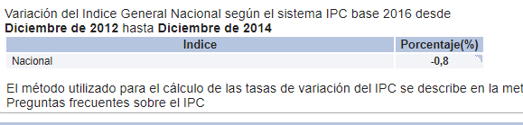
So, how did you get the -2.8%? A real mistery.
Summary 2011-2014
In summary, between December 2011 and December 2014, the index increased actually to 102 [100 * (1+0.029) * (1-0.008)], that is, a 2% increase.
So, applying a REAL 2.9% increase in April 2013 and a WRONG 2.8% decrease in April 2015 means that under the local track UN pensioners living in Spain have suffered a lost of 2% of their purchasing power in terms of their floor pension starting from the latter date.
Of course, since the dollar raised a lot in 2014-2016, retirees in the local track in Spain got more money than expected, they were happy, and did not bother to check the COL figures.

2014-2016
Concerning 2014-2016, in one of the messages I got from UNJSPF, I was told that there would be no change in the pension in April 2017, since the COL increase was +1.6% during that period. I have checked that with the INE calculator and yes, it gives me exactly that figure: +1.6%. Here is a screenshot:
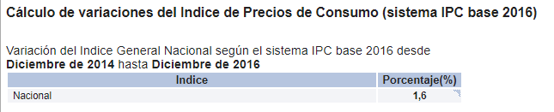

Conclusions concerning 2011-2016
The UNJSPF data for 2011-2012 and 2014-2016 match very well with the INE data. This fact is an additional argument for considering that, concerning the data for 2012 -2014, the Fund made a serious mistake (to say the least) when using -2.8% instead of -0,8%.
Instead of recognizing that mistake, after my inquiries, the Fund has decided to add another mistake (considering that +2.9% was wrong). A mistake that –surprise!- is the opposite of the first one and has the same magnitude, so they cancel each other out.
In the graph below we can see the difference between the real index and the wrong index, taking the 2011 value as 100. From now on, if there is no change, Spanish pensioners will get 2% less money each month whenever the dollar falls below the exchange rate guaranteed when retiring.

 |  |  | 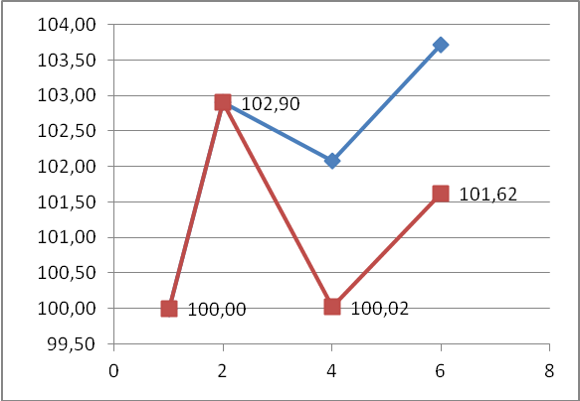
 | real COL | WRONG COL
2011 | 100,00 | 100,00
2012 | 102,90 | 102,90
2014 | 102,08 | 100,02
2016 | 103,71 | 101,62
 | REAL COL | WRONG
1 | 100,00 | 100,00
2 | 102,90 | 102,90
4 | 102,08 | 100,02
6 | 103,71 | 101,62

AN EASY SOLUTION
The Fund has underlined to me the content of Section G, paragraph 14 of the UNJSPF Pension Adjustment System. Let’s have a look at it:

14. For measuring changes in the CPI for the United States and for a particular country of residence, the index used is the official CPI for the country as a whole issued by the national Government and published in the United Nations Monthly Bulletin of Statistics. Where no such index is published in the United Nations Monthly Bulletin of Statistics for a particular country or area, another regularly published index specified by the Statistics Division of Department of Economic and Social Affairs of the United Nations may be utilized. Once an index has been utilized to give effect to an adjustment, any subsequent amendment or correction of that index will not give rise to retroactive correction of the adjustment.
I was told twice that, as specified therein, there can be no retroactive correction of the adjustment. That is, no one could claim the 2% difference RETROACTIVELY. I agree. However, this does not prevent the Fund from correcting the adjustment IN THE FUTURE. For example, by increasing the index in 2 percentage points in April 2018 in addition to the increase observed between December 2014 and December 2017. There is no reason to feel constrained by that paragraph.

